Product specific techniques

IBM DB2 11.5

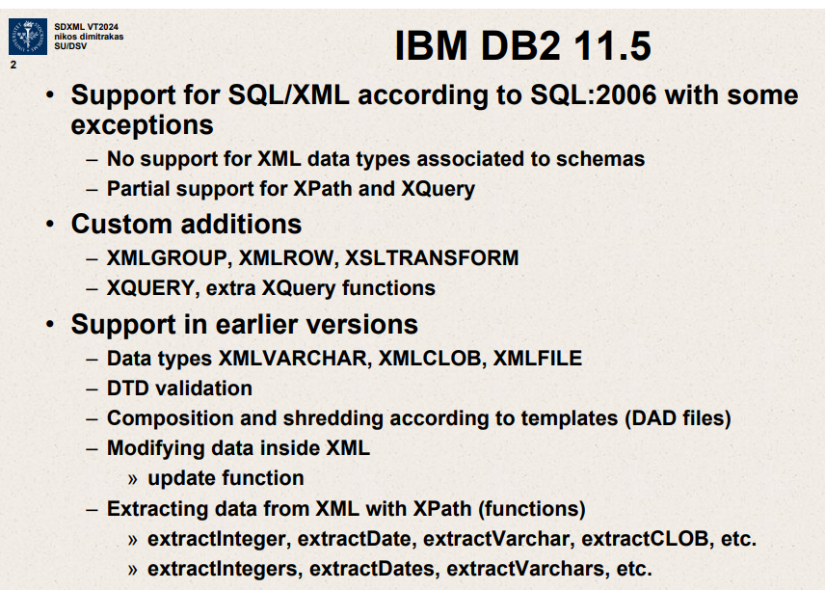

The slide from the image summarizes the support and capabilities of IBM DB2 version 11.5 for handling SQL/XML, along with some custom features and support changes over previous versions. Here’s a detailed breakdown:

**Support for SQL/XML According to SQL:2006**

IBM DB2 11.5 adheres largely to the SQL:2006 standards for SQL/XML integration, with some noted exceptions and enhancements:

**Exceptions:**

* **No Support for XML Data Types Associated to Schemas: DB2 does not provide support for certain XML data types that are directly linked to XML Schemas. This might affect scenarios where strict schema validation and typing are required.**
* **Partial Support for XPath and XQuery**: While DB2 supports XPath and XQuery, the support is partial, which may limit the complexity of queries or functions that can be executed directly in SQL statements.

**Custom Additions**

DB2 11.5 includes several custom extensions to standard SQL/XML functionalities, which enhance its capability to work with XML data:

* **XMLGROUP and XMLROW**: Custom functions for grouping and row operations in XML data processing.
* **XSLTRANSFORM**: Provides the ability to transform XML data using XSLT (Extensible Stylesheet Language Transformations) directly within SQL queries.
* **XQUERY and Extra XQuery Functions**: Enhanced support for XQuery expressions and additional functions, expanding the scope and usability of XQuery for more complex XML data manipulations.

**Support in Earlier Versions**

**The slide also details features that were supported in earlier versions of DB2, providing a historical perspective on the evolution of XML handling:**

* **Data Types**: Support for XML data types like **XMLVARCHAR**, **XMLCLOB**, **XMLFILE**, which facilitated operations on XML content as strings, large text blocks, and external XML files, respectively.
* **DTD Validation: Support for validating XML documents against DTDs (Document Type Definitions) to ensure they conform to specified layouts and rules.**
* **Composition and Shredding According to Templates (DAD files)**: DAD files, or Data Access Descriptors, used to define how XML data is mapped to database columns or how relational data is encapsulated into XML.
* **Modifying Data Inside XML**: Functions to update XML data directly, allowing for dynamic data manipulation within XML columns.
* **Extracting Data From XML with XPath Functions**: Functions like **extractInteger**, **extractDate**, **extractVarchar**, etc., for pulling specific data types from XML documents using XPath.

**Practical Implications**

The capabilities and exceptions highlighted for IBM DB2 11.5 suggest a robust environment for integrating XML with traditional relational databases, with enhanced functionality for transforming and querying XML data. This makes DB2 suitable for applications requiring complex XML data interactions, such as data exchange systems, configuration management databases, or any system where XML is a primary data format.

Understanding these features helps in leveraging DB2 effectively for database designs that involve extensive use of XML, planning migrations, or upgrades from earlier versions, and integrating with applications where precise XML manipulations are crucial.

IBM DB2 has support for SQL/XML according to SQL:2006 with some exceptions.

No support for XML data types associated to schemas.

Partial support for Xpath and Xquery.

Custom additions

XMLGROUP, XMLROW, XSLTRANSFORM

Xquery ,extra Xquery functions

Support in earlier versions

Data types XMLVARCHAR, XMLCLOB, XMLFILE

DTD validation

Composition and shredding according to templates(DAD files)

Modifying data inside XML.

Update function

Extracting data from XML with Xpath (functions)

-extractInteger,extractDate,extractVarchar,extractCLOB

-extractIntegers,extractDates,extractVarchars.

DB2 specific functionality

What does DB2 support or not support

IBM DB2 11.5

Support for SQL/XML according to SQL:2006 with some exceptions.

-No support for XML data types associated to schemas.

Partial support for Xpath and Xquery.

Custom additions

XMLGROUP, XMLROW ,XSLTRANSFORM

Xquery, extra Xquery functions

Support in earlier versions

Data types XMLVARCHAR,XMLCLOB, XMLFILE  
  
DTD validation

Composition and shredding according to templates (DAD files)

Modifying data inside XML

IBM DB2 11.5

Support for SQL/XML according to SQL:2006 with some exceptions.

No support for XML data types associated to schemas.

Partial support for Xpath and Xquery

Custom additions

XMLGROUP ,XMLROW,XSLTRANSFORM

Xquery,extra Xquery functions

Support in earlier versions

Data types XMLVARCHAR, XMLCLOB, XMLFILE

DTD validation  
Shredding XML according to templates(DAD files)

Document Access Definition

Composition and shredding according to templates(DAD files)

Modifying data inside XML

* Update function

Extracting data from XML with Xpath (functions)

extractInteger, extractDate ,extractVarchar, extractCLOB

extractIntegers,extractDates,extractVarchars,etc.

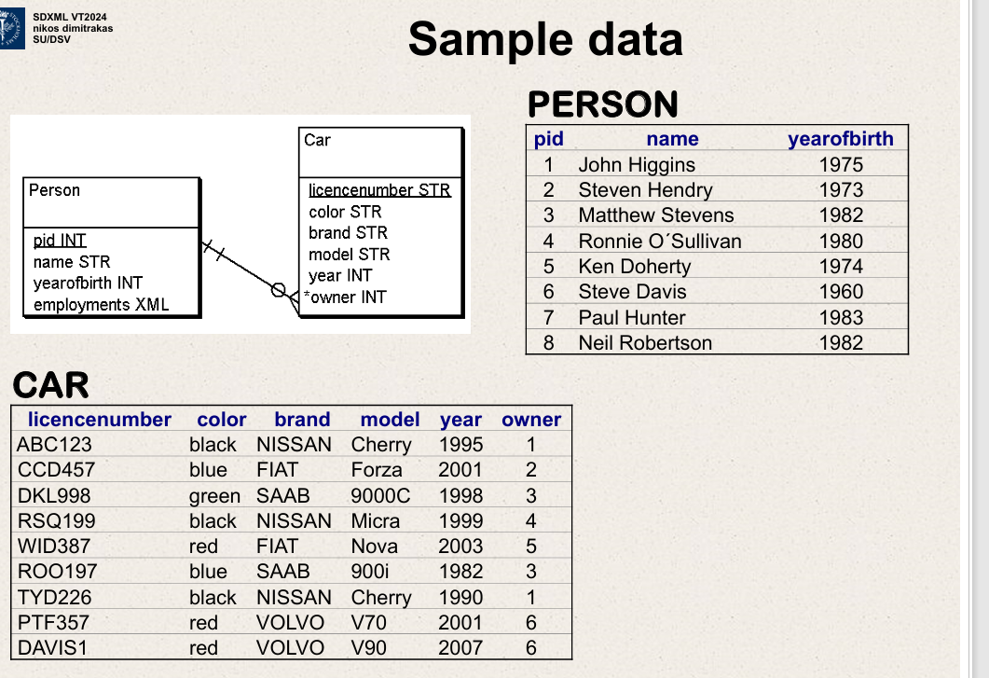

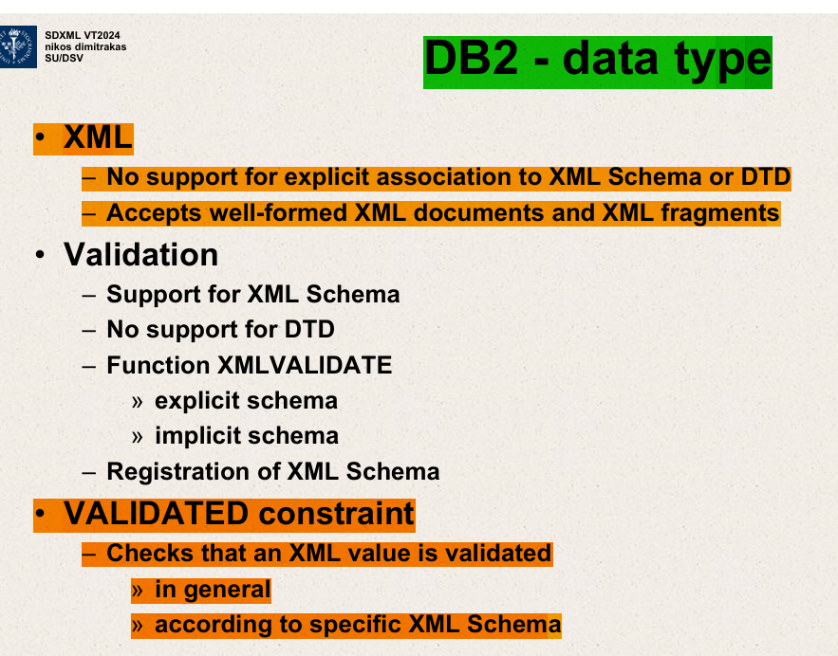

The slide you provided highlights specific features of IBM DB2 related to XML data handling, focusing on XML data type support, validation capabilities, and constraints. Here's a detailed explanation of each point outlined in the slide:

**XML Support in IBM DB2**

1. **No Support for Explicit Association to XML Schema or DTD**:
   * IBM DB2 does not support directly associating XML documents stored within the database with an XML Schema (XSD) or Document Type Definition (DTD). This means while you can store and manage XML data, the association between the data and its schema must be handled externally or implicitly within applications.
2. **Accepts Well-formed XML Documents and XML Fragments**:
   * DB2 ensures that all XML data stored is well-formed, adhering to the basic syntactical rules of XML. However, the responsibility of ensuring that the XML is valid per specific schema rules does not automatically happen at the database level without additional setup or application logic.

**XML Validation**

1. **Support for XML Schema**:
   * DB2 supports XML Schema, which allows for the validation of XML documents against defined schemas to ensure data integrity and adherence to specified data structures.
2. **No Support for DTD**:
   * Unlike XML Schema, DB2 does not support DTDs, which are another method of defining the structure and legal elements and attributes of XML documents. Users of DB2 need to rely on XML Schema for any needs related to defining and validating the structure of XML data.
3. **Function XMLVALIDATE**:
   * **Explicit Schema**: This function can validate XML data against an explicitly provided XML Schema. This is useful for operations where the schema needs to be specified at the time of validation.
   * **Implicit Schema**: DB2 also allows for the validation of XML data against schemas that have been registered with the database, allowing for a more integrated and automated approach to XML validation.
4. **Registration of XML Schema**:
   * DB2 allows for XML Schemas to be registered within the database. This registration helps in managing and utilizing schemas more effectively, especially for validation operations using the **XMLVALIDATE** function.

**VALIDATED Constraint**

1. **Checks that an XML Value is Validated**:
   * This constraint ensures that any XML data inserted or updated in the database meets certain validation criteria, helping to maintain data quality and adherence to business rules.
   * **In General**: This can apply to basic well-formedness checks.
   * **According to Specific XML Schema**: More commonly, this involves validation against a specific XML Schema, ensuring that the data conforms to the detailed specifications outlined in the schema.

This slide underlines DB2’s capabilities and limitations in handling XML data, emphasizing its robust support for XML Schemas while noting the lack of support for DTDs. The focus on schema-based validation and constraints shows a commitment to ensuring data integrity and compliance with business rules within the database environment. These features are particularly relevant in environments where XML data is extensively used and where data consistency and validity are critical, such as in financial services, healthcare, and other enterprise applications.

The statement regarding "no support for explicit association to XML Schema or DTD" combined with "validation support for XML Schema" in the context of IBM DB2 refers to specific capabilities and limitations in how XML data is handled and validated within the database system.

**No Support for Explicit Association to XML Schema or DTD**

This part means that DB2 does not have built-in mechanisms to directly bind or link XML data columns to a specific XML Schema (XSD) or Document Type Definition (DTD) within the database definition or schema.

In other database systems or XML processing environments, you might find functionality where an XML column or XML data type can be explicitly defined to conform to a particular XML Schema directly in the table definition. This association ensures that any XML data inserted into the column automatically adheres to the specified schema or DTD.

In DB2, this automatic, direct linkage at the database schema level is not supported, which means:

* XML data stored in DB2 can be any well-formed XML.
* The responsibility to ensure that the XML data conforms to a specific schema often falls to the application layer, or must be enforced manually through explicit validation steps during data processing.

**Validation Support for XML Schema**

Despite the lack of explicit schema association at the database level, DB2 does support XML Schema for validation purposes. This is primarily handled through the **XMLVALIDATE** function. Here’s how it works:

* **XMLVALIDATE Function**: This function can be used to validate XML documents against a specified XML Schema. This validation can be performed as part of SQL queries, stored procedures, or triggers.
* **Registration of XML Schemas**: DB2 allows for XML Schemas to be registered with the database. Once registered, these schemas can be referenced in **XMLVALIDATE** operations, enabling implicit validation where the schema does not need to be specified each time validation is performed.

**Practical Implications**

The distinction between these features means that while DB2 can store any well-formed XML and does not inherently enforce XML schema constraints on XML data at the storage level, it does provide the tools needed to perform validation against XML Schemas at runtime. This setup offers flexibility but requires more management at the application level or through explicit validation steps integrated into data handling processes.

Thus, while you can't define a table in DB2 that automatically enforces XML conformity to a schema on data insertion (explicit association), you can still ensure data adheres to specific XML schemas through validation functions (validation support). This approach allows applications using DB2 to maintain robust data integrity checks, provided these checks are correctly implemented in the data handling logic.

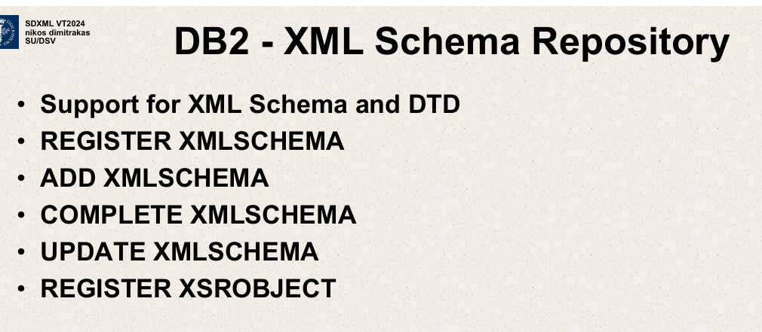

The slide discusses features related to the XML Schema Repository in IBM DB2, emphasizing the management of XML Schemas within the database system. Here’s a breakdown of the functionalities and operations mentioned:

**DB2 - XML Schema Repository**

**1. Support for XML Schema and DTD**

* While DB2 has no explicit support for associating DTDs with XML data types,

DB2 - it does provide robust support for XML Schema.

This support allows you to define, store, and manage XML Schemas within the DB2 environment, ensuring XML data adheres to specific structures and rules defined by these schemas.

**2. REGISTER XMLSCHEMA**

* This operation is used to register an XML Schema with the DB2 database. By registering a schema, you make it available in the database for validation and other operations. This does not link the schema to any specific XML column or data type directly but makes it part of the database’s schema repository for use.

**3. ADD XMLSCHEMA**

* This command adds a new XML Schema to the repository. This could be the initial step in introducing a new schema into the database environment before it is fully registered or used in operations.

**4. COMPLETE XMLSCHEMA**

* Once an XML Schema is added, there might be a requirement to mark it as complete or finalized. This step could be necessary to move the schema from a preliminary stage where it might still be editable, to a finalized stage where it is locked down for validation uses.

**5. UPDATE XMLSCHEMA**

* If changes are needed to an existing schema (e.g., to adjust for changes in data structure or business rules), this operation allows you to update the schema already registered in the database. This capability is crucial for maintaining the relevance and accuracy of data validation as business needs evolve.

**6. REGISTER XSROBJECT**

* This likely refers to the registration of XML Schema-related objects, which could include complex types or elements defined within a schema. Registering these objects might be necessary for them to be recognized and used within the DB2 XML processing environment, especially if they are used in custom XML processing or validation functions.

**Practical Use and Importance**

The management of XML Schemas within DB2 is crucial for applications where XML data plays a significant role. Proper schema management ensures:

* **Consistency**: XML data stored in the database adheres to defined formats and structures.
* **Data Integrity**: Validations against a schema prevent corrupt or invalid data from being stored, enhancing overall data quality.
* **Adaptability**: Updating schemas allows the database to adapt to changing data requirements without compromising existing data integrity.

For enterprises and applications where XML data integration is essential, such as in financial services, healthcare, or e-commerce, these tools provide essential support for maintaining robust and flexible data management practices.

The capabilities highlighted in this slide are indicative of a system that supports high levels of data governance and adaptability to changing technical and business environments.

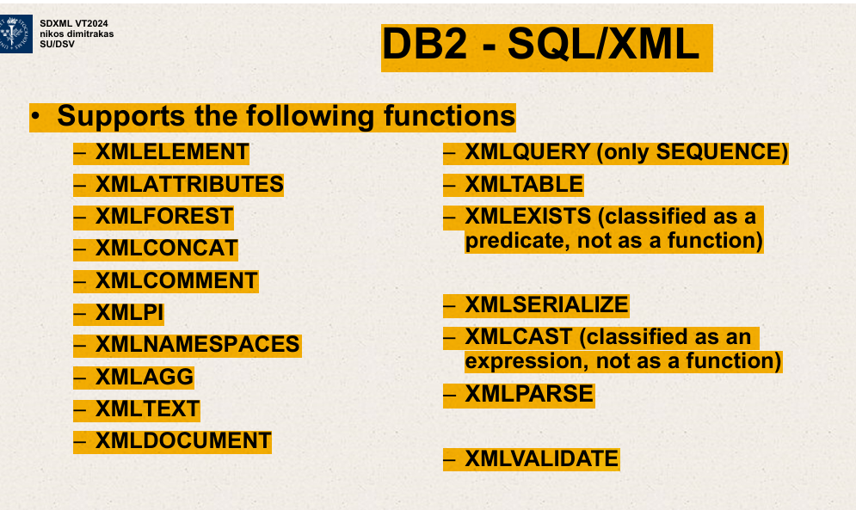

The image outlines a list of SQL/XML functions supported by IBM DB2, which facilitate the integration, manipulation, and querying of XML data within SQL. These functions are essential for applications where XML data interacts extensively with relational databases. Here’s a breakdown of these functions:

**XML Construction Functions**

* **XMLELEMENT**: Creates an XML element with a specified name and content.
* **XMLATTRIBUTES**: Generates XML attributes for elements, often used within **XMLELEMENT**.
* **XMLFOREST**: Creates a set of XML elements from various expressions.
* **XMLCONCAT**: Concatenates multiple XML fragments into a single XML fragment.
* **XMLCOMMENT**: Produces an XML comment.
* **XMLPI (Processing Instruction)**: Generates an XML processing instruction, used for passing information to applications.
* **XMLNAMESPACES**: Declares namespaces to be used within an XML expression.
* **XMLAGG**: Aggregates multiple XML elements into a single element.
* **XMLTEXT**: Converts SQL data types to XML text nodes.
* **XMLDOCUMENT**: Ensures that the output is a well-formed XML document.

**XML Query and Manipulation Functions**

* **XMLQUERY**: Executes an XQuery against XML data, returning sequences or atomic values.
* **XMLTABLE**: Transforms XML data into relational rows and columns, allowing it to be queried with SQL.
* **XMLEXISTS**: Checks if a specified XQuery returns a non-empty result. Classified as a predicate, it's used for conditionals in SQL queries.
* 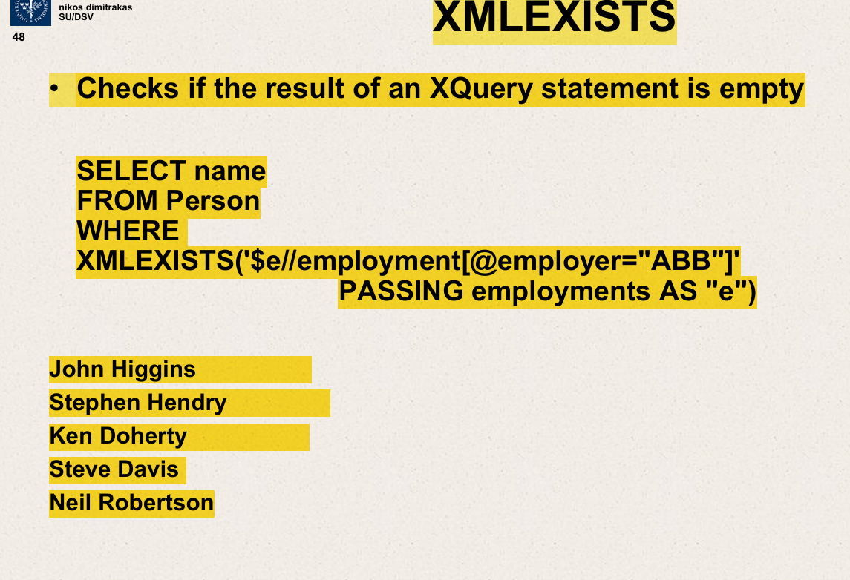
* **XMLSERIALIZE**: Converts XML data into a character string in a specified character set.
* **XMLCAST**: Casts XML data into specified SQL data types. It's classified as an expression rather than a function.
* **XMLPARSE**: Parses a character string as XML, verifying that it's well-formed.
* **XMLVALIDATE**: Validates an XML document against a registered XML Schema.

**Usage and Importance**

* These functions are crucial for scenarios where DB2 is used to store, retrieve, and manage XML data alongside traditional relational data. This can be in contexts like data exchange interfaces, configurations, and scenarios where semi-structured data is prevalent.
* Functions like **XMLTABLE** and **XMLQUERY** bridge the gap between XML and relational models, enabling powerful data integration solutions.
* The construction functions like **XMLELEMENT** and **XMLFOREST** are instrumental in generating XML from relational data, supporting dynamic XML generation based on database queries.
* Validation and parsing functions ensure data integrity and compliance with standards, which is critical in enterprise environments where XML data must adhere to defined schemas for interoperability reasons.

The ability to handle and manipulate XML data natively within SQL queries greatly enhances DB2’s versatility for modern applications that require robust data interaction capabilities across different data formats.

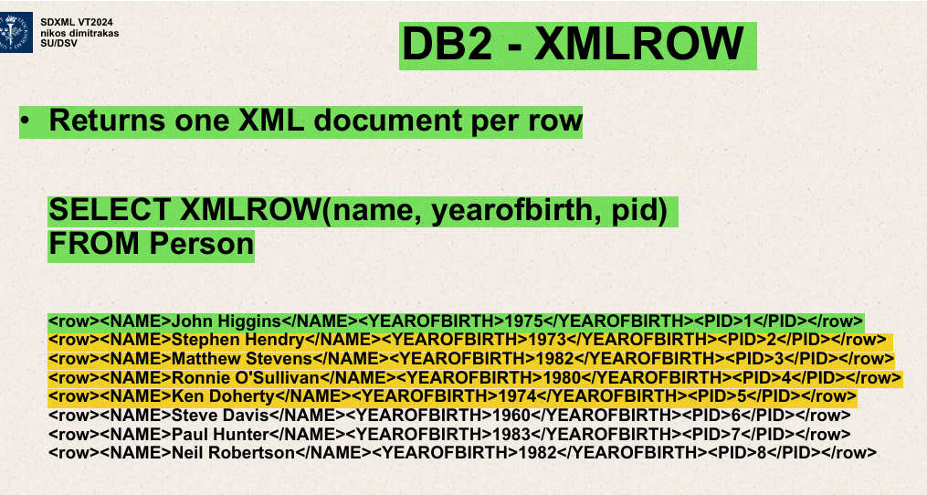

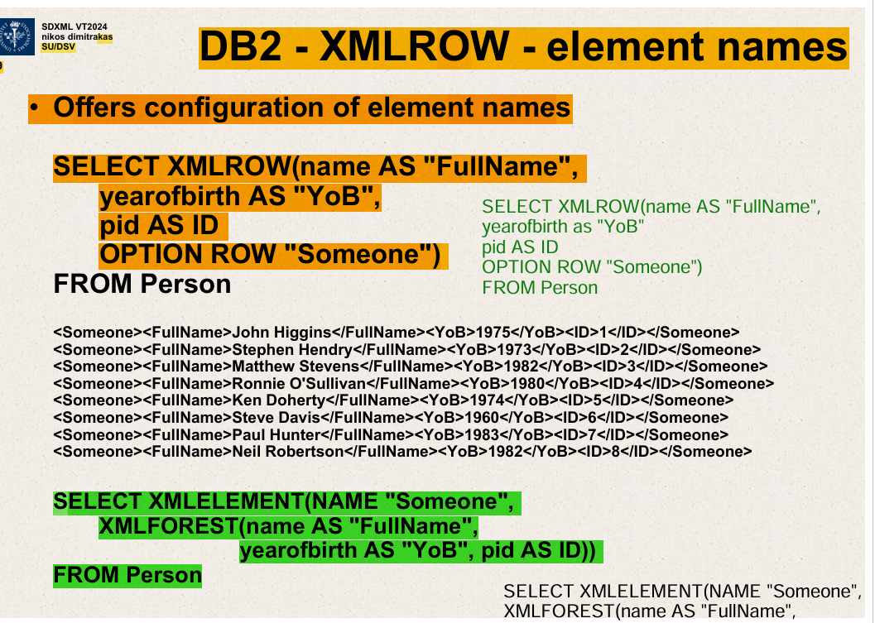

Offers a way to change all the element names.

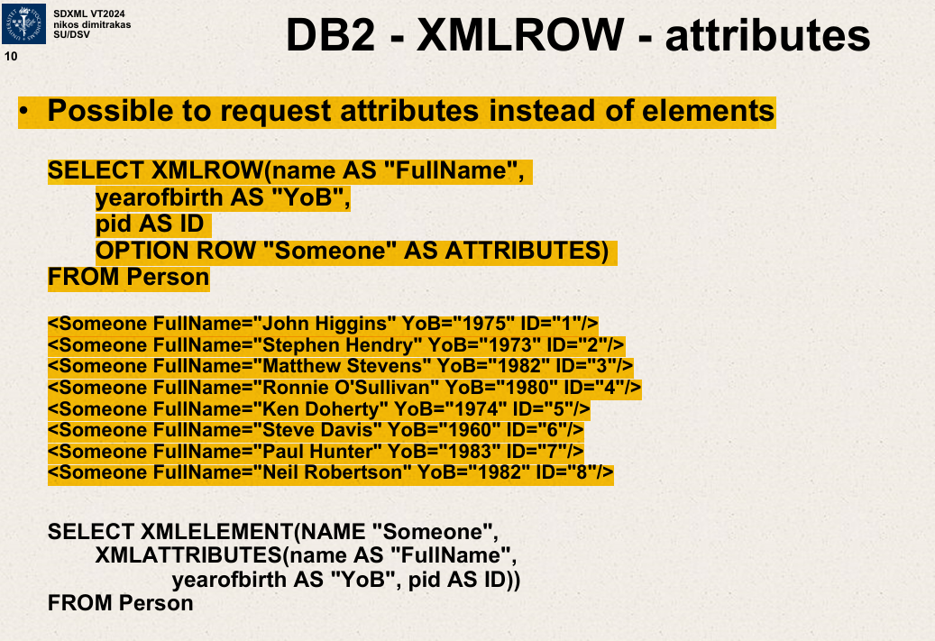

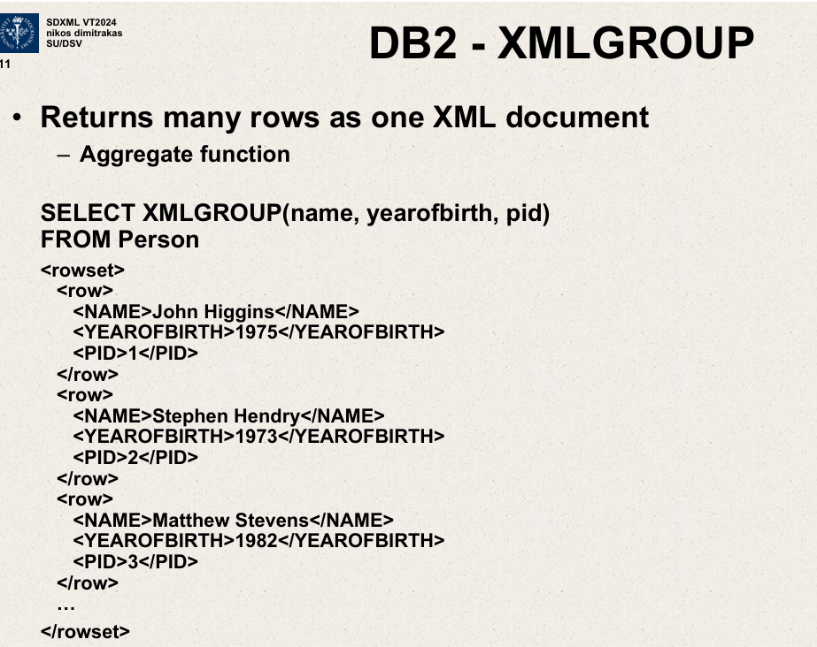

DB2 data type

XML – no support for explicit association to XML schema or DTD.

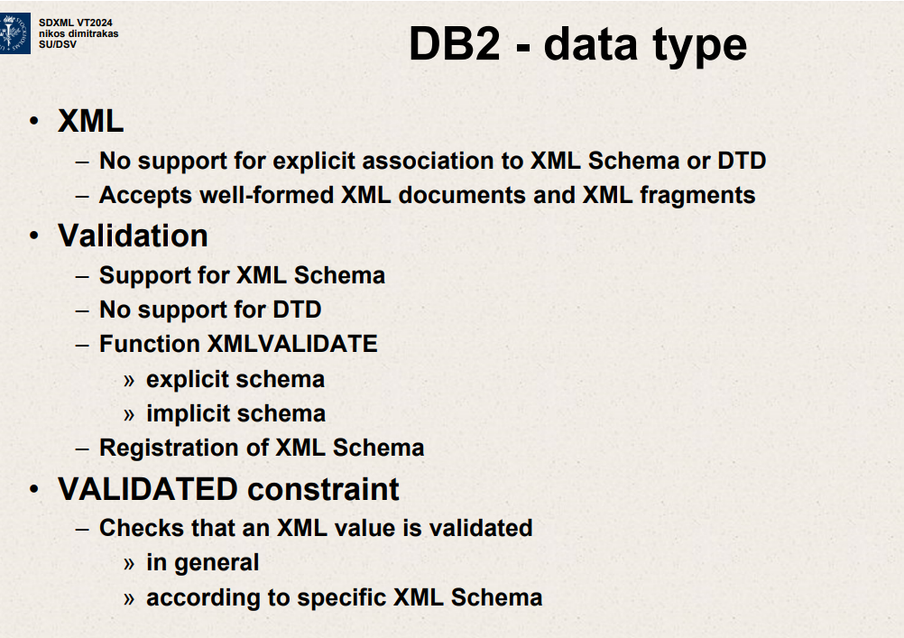

DB2 has a data type for XML called

XML

No support for explicit association to XML schema or DTD.

Accepts well formed XML documents and XML fragments

Validation

Support for XML schema

No support for DTD

Function XMLVALIDATE

* Explicit schema
* Implicit schema

Registration of XML schema

VALIDATED constraint

Checks an XML value is validated.

In general - according to specific XML schema.

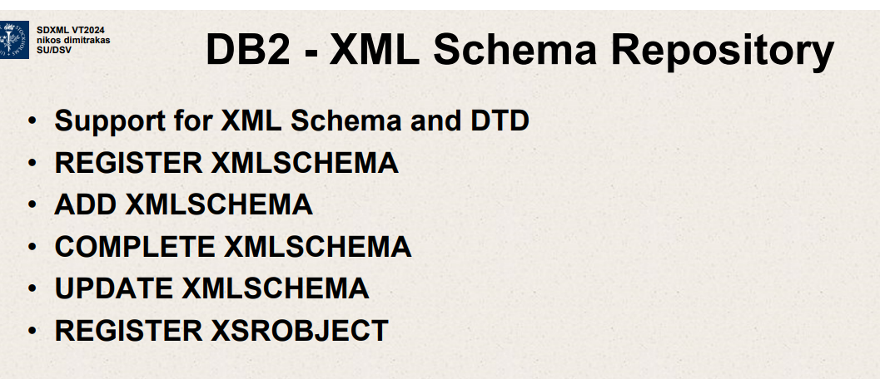

Special commands you need to register an XML schema,

Maybe give it a name ,then add XML schema with URL and actual schema document.

It supports XML schema ,it does not support DTD

Support for XML schema and DTD  
REGISTER XMLSCHEMA  
ADD XMLSCHEMA

COMPLETE XMLSCHEMA  
UPDATE XMLSCHEMA  
REGISTER XSROBJECT

We need to inform DB2 about existence of XMLSCHEMA.

Create XML schema as an object and then use that object as a reference when we do that constraint.

VALIDATED constraint

Checks that an XML value is validated

In general.

according to a specific XML schema.

When does the constraint kick in

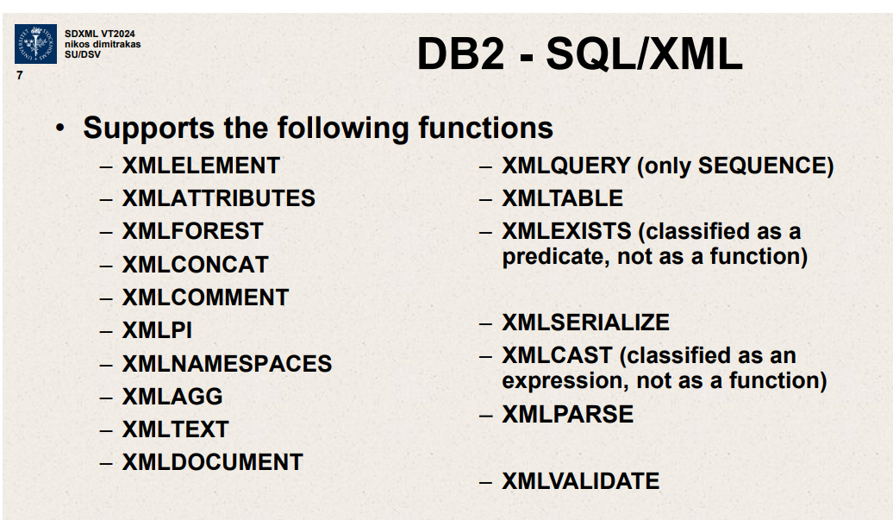

We had a bunch of functions.

I had them in these groups. You had the composition ones.

And then we had support ones. To convert between the types and validate.

XMLELEMENT,XMLATTRIBUTES,XMLFOREST,XMLCONCAT,

XMLCOMMENT,XMLPI,XMLNAMESPACES,XMLAGG,

XMLTEXT,XMLDOCUMENT,XMLTABLE,XMLQUERY,XMLPARSE,XMLVALIDATE.

FOREST, CONCAT, AGG to aggregate or merge things.

Kind of full support.

On right side XMLQUERY,XMLTABLE,XMLEXISTS

We have forest ,concat, agg to aggregate or merge things.

Kind of full support.

On right side ->XMLQUERY,XMLTABLE,XMLEXISTS.

All 3 exist but have certain limitations.

XMLQUERY – only supports a sequence ,but not content.

Supposed to be 2 modes, it won’t bother us at all .

Sequence is – a sequence of one thing , then it will be fine.

XMLTABLE – doesn’t have any known limitations, then XMLEXISTS itself is fine but some reason in documentation, don’t call this a function.

This one they call it expression but not a function.

When we call these nice functions that do exist,limited to what our Xquery expressions are allowed to do.

Function itself is there but content of function maybe restricted

Because they don’t allow certain dynamic element names.

They don’t allow certain reverse axis.

Cannot do preceding sibling or something like that.

They don’t support that ,they haven’t implemented it.

DB2 - XMLROW

Returns one XML document per row.

Select XMLROW( name, yearofbirth, pid)

FROM Person

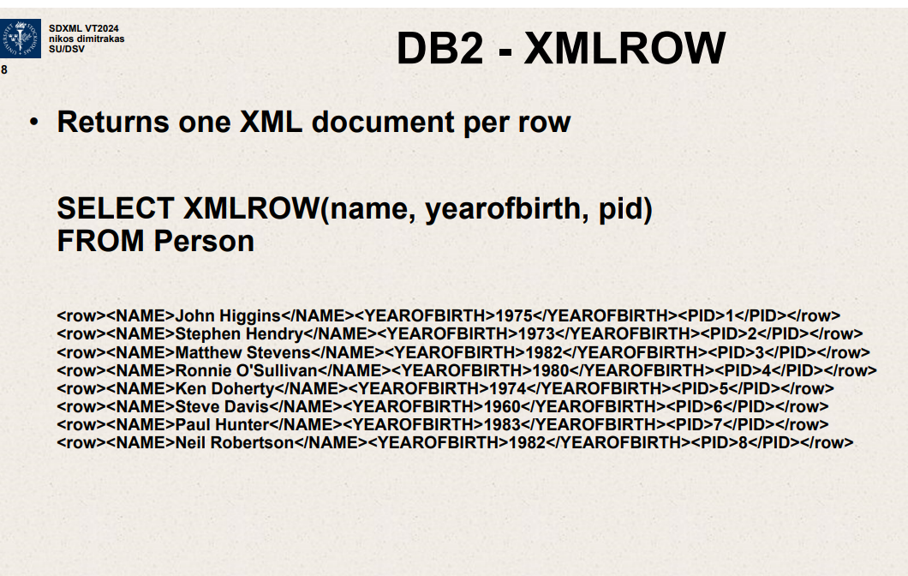

Document that start with a row

For every column I have added there inside the function, it will create an element with a text node with a value from that cell in the table.

DB2-XMLROW-element names

Offers configuration of element names

SELECT XMLROW(name AS “FullName”,

Yearofbirth AS “YoB”,

Pid as ID

OPTION ROW “Someone”)

FROM Person

DB2-XMLROW

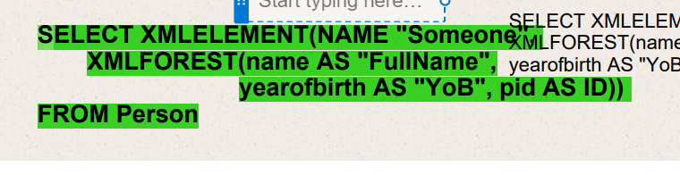

DB2 – XMLGROUP – attributes

Possible to request attributes instead of elements.

SELECT XMLGROUP(name AS “FullName”,yearofbirth AS “YoB”,

pid AS ID OPTION AS ATTRIBUTES

ROOT “Everyone” ROW “Someone”

FROM Person

DB2 – XSLTRANSFORM

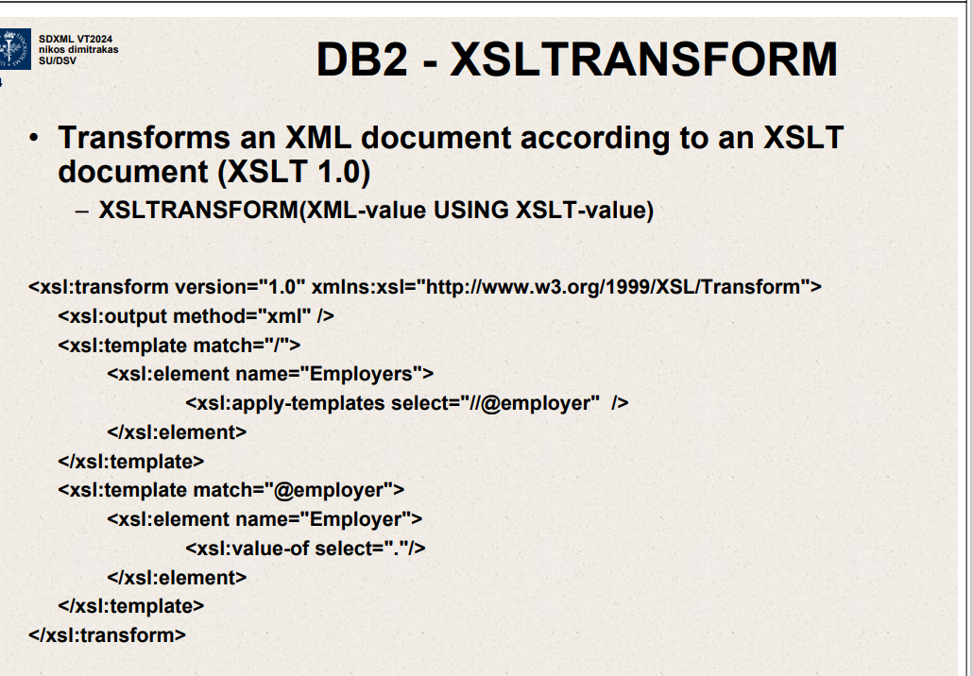

Transforms an XML document according to an XSLT document

(XSLT 1.0)

XSLTRANSFORM (XML value using XSLT value)

Transforms an XML document according to XSLT document

XSLTRANSFORM (XML value using XSLT value

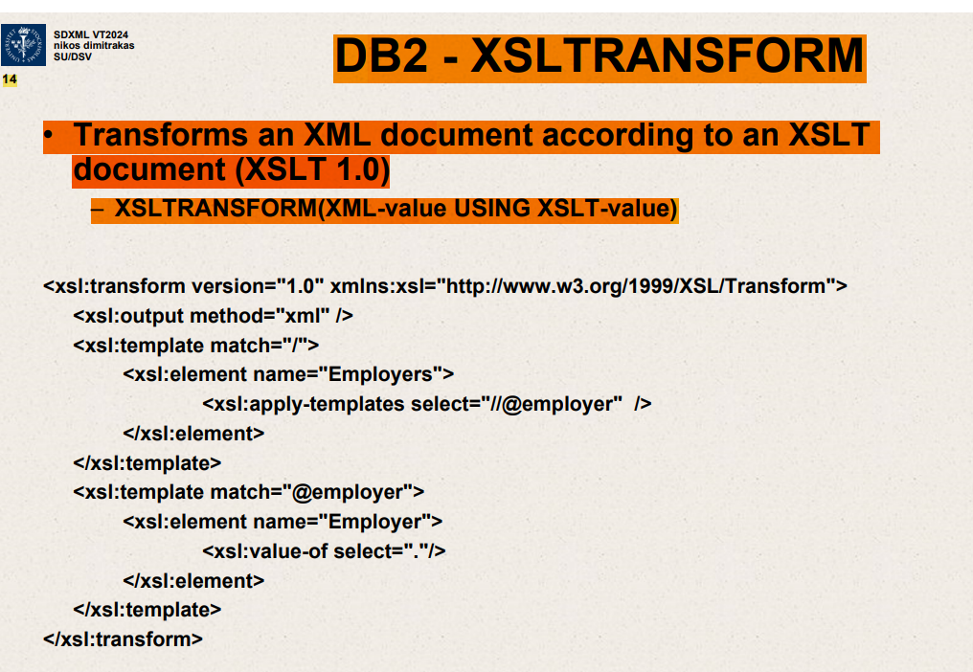

Transforms an XML document according to an XSLT document.

(XSLT 1.0)

DB2 – XMLCAST  
Converts between XML and other data types.

SELECT name, XMLCAST(XMLQUERY

(‘count($EMPLOYMENTS//employment)’) AS INT)  
FROM PERSON

DB2-Xquery

Support for Xquery

XQuery statements after keyword XQUERY.

Xquery

for $a in (1,2,3)

return element Number {$a}

element Result { for $a in (1,2,3)

return element Number{$a} }

<Result>

Xquery function for SQL inside Xqueryd

db2-fn:sqlquery

-supports parameters

Result is a sequence in the Xquery context

SELECT statement must return one XML column

Xquery function for SQL inside Xquery

For $a in distinct-values

DB2 – XML DML

Xquery Update Facility

-some syntax differences

Transform statements

Copy clause

Modify clause

-do delete

-do insert

-do rename

-do replace

Return clause

-keywords for do insert

before

after

as first into

as last into  
into

The whole XML value in a cell must be replaced

UPDATE Person

SET employments=XMLQUERY ( ‘transform statement’

PASSING employments

WHERE…

DB2 – transform -insert

Xquery

Transform

copy $x:= <root><a> 456</a><a>789</a></root>

Modify do insert <a>123</a> before $x/a[text()=789]

return $x

<root>

<a>456</a>

<a>123</a>

<a>789</a>

</root>

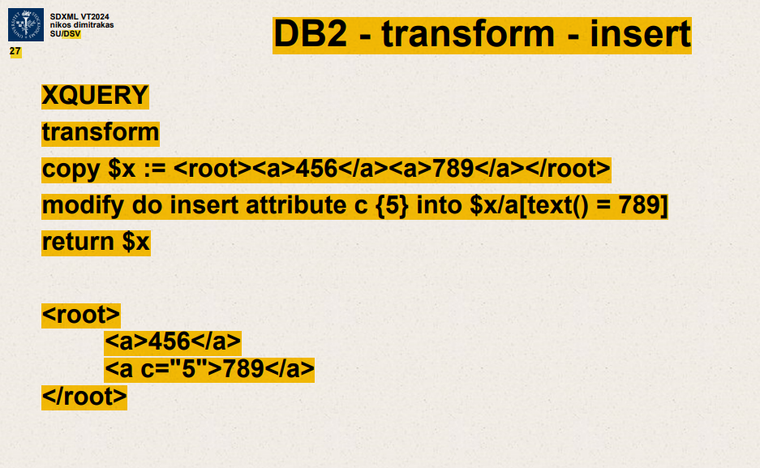

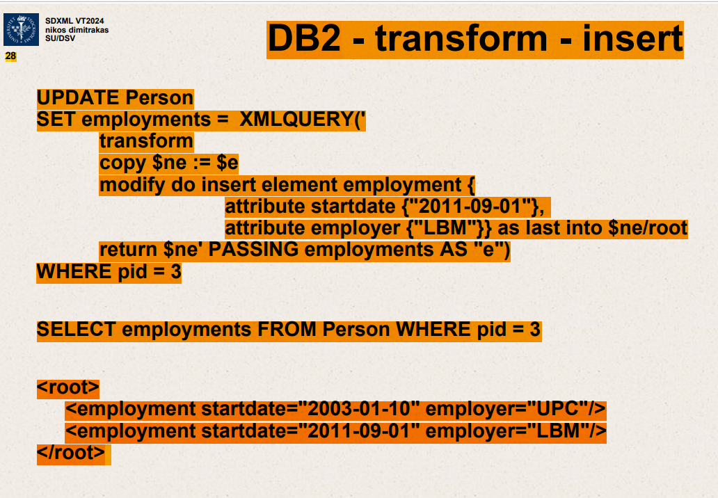

It looks like the image you uploaded shows SQL and XML code used to update and query a database. The code demonstrates how to use **XMLQUERY** in SQL to manipulate XML data stored within a database. Specifically, it involves inserting a new employment record into an XML data structure for a person identified by **pid = 3**.

Here’s a breakdown of what the code is doing:

1. **Update Statement**:
   * **UPDATE Person**: This command is updating records in the **Person** table.
   * **SET employments = XMLQUERY(...) WHERE pid = 3**: This updates the **employments** column for the person with **pid = 3** using the result of the **XMLQUERY**.
2. **XMLQUERY Function**:
   * It uses an XQuery expression to transform existing XML data.
   * **transform copy $ne := $e**: This creates a copy of the existing XML node.
   * **modify do insert element employment {...} as last into $ne/root**: This inserts a new **<employment>** element at the end of the root node in the copied XML.
   * The new **<employment>** element has a **startdate** attribute of "2011-09-01" and an **employer** attribute of "LBM".
3. **Returning the Modified XML**:
   * **return $ne**: This returns the modified XML structure which now includes the new employment data.
4. **SELECT Statement**:
   * After the update, the SELECT statement fetches the **employments** XML data from the **Person** table where **pid = 3** to show the updated XML data.

The result below the SQL statements shows that the **employments** column now includes two **<employment>** elements:

* The original employment from "2003-01-10" with employer "UPC".
* The newly inserted employment from "2011-09-01" with employer "LBM".

This type of SQL/XML integration is particularly useful for managing structured data within a relational database that also needs to handle XML data effectively.

Top of Form